SAPiD: 500097692 Name: Deepanshu Rawat

**System Provisioning and Configuration Management**

**Lab File**

**(2023-2024)**

**for**

**6th Semester**

|  |  |
| --- | --- |
| Submitted To:  Dr. Silky Goel | Submitted By:  Deepanshu Rawat  B. Tech. CSE DevOps  [6th Semester]  Sap id- 500097692  Batch – 1(Hons) DevOps |

Experiment: 1

TITLE: Terraform Basics

* Setup the AWS provider for terraform

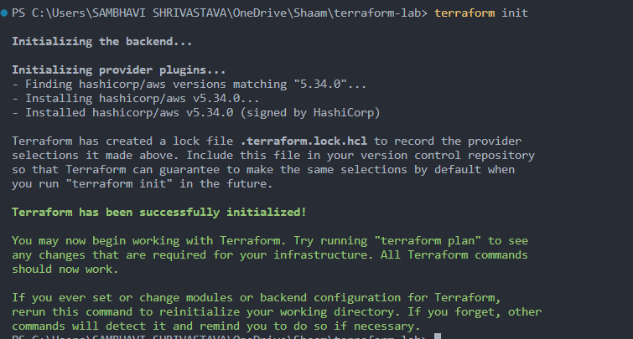

* Configure the AWS provider with the access key and secret key
* Create a new EC2 with a tag  
  + Main.tf file for the configurations of EC2

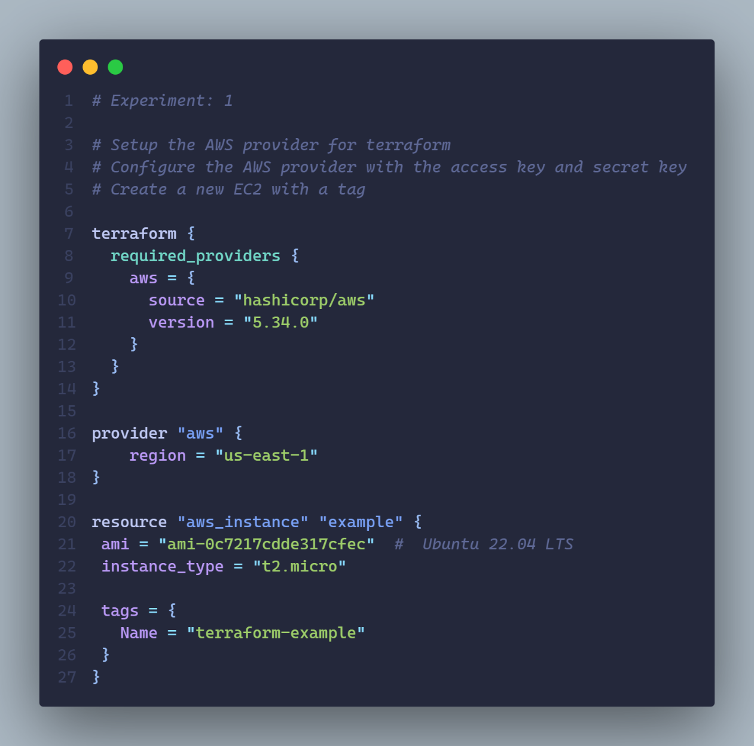

* + Executing: terraform plan

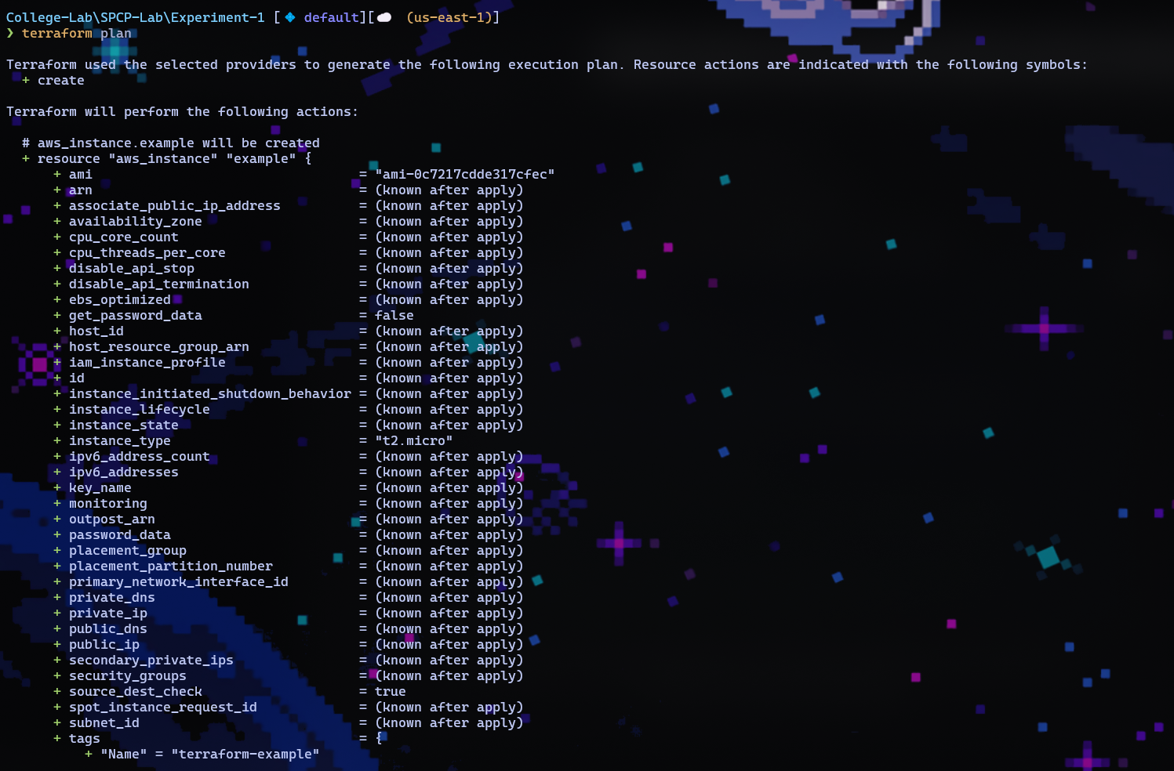

* + Executing: terraform apply

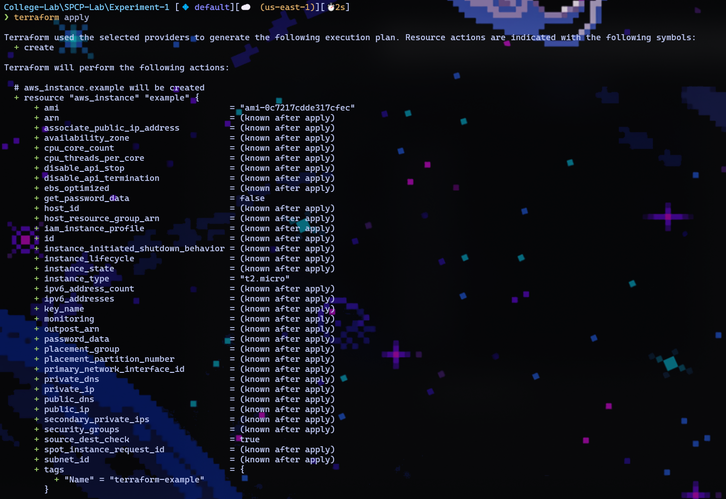

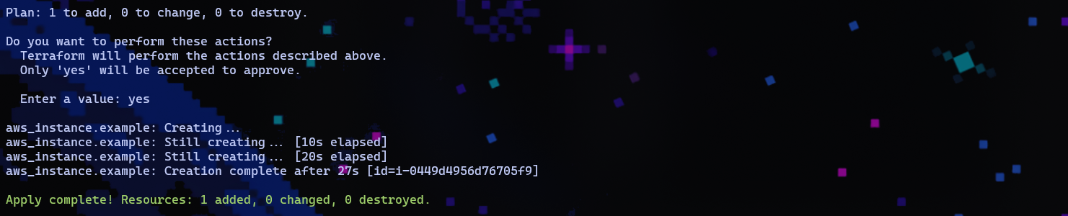

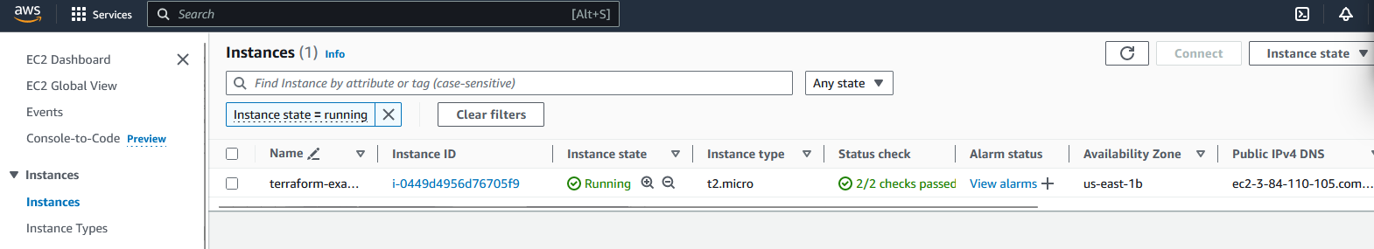

Experiment: 2

TITLE: Terraform Basics

* Create a S3 Bucket
* Enable versioning on the S3 bucket
* Add an upload file from folder to the S3 bucket
* Give public access to the S3 bucket

Main.tf File:

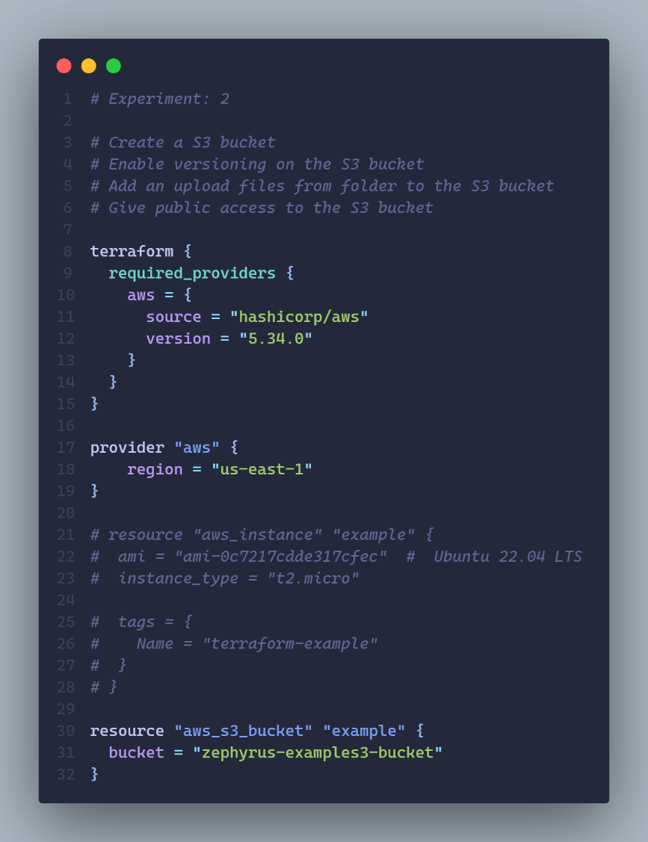

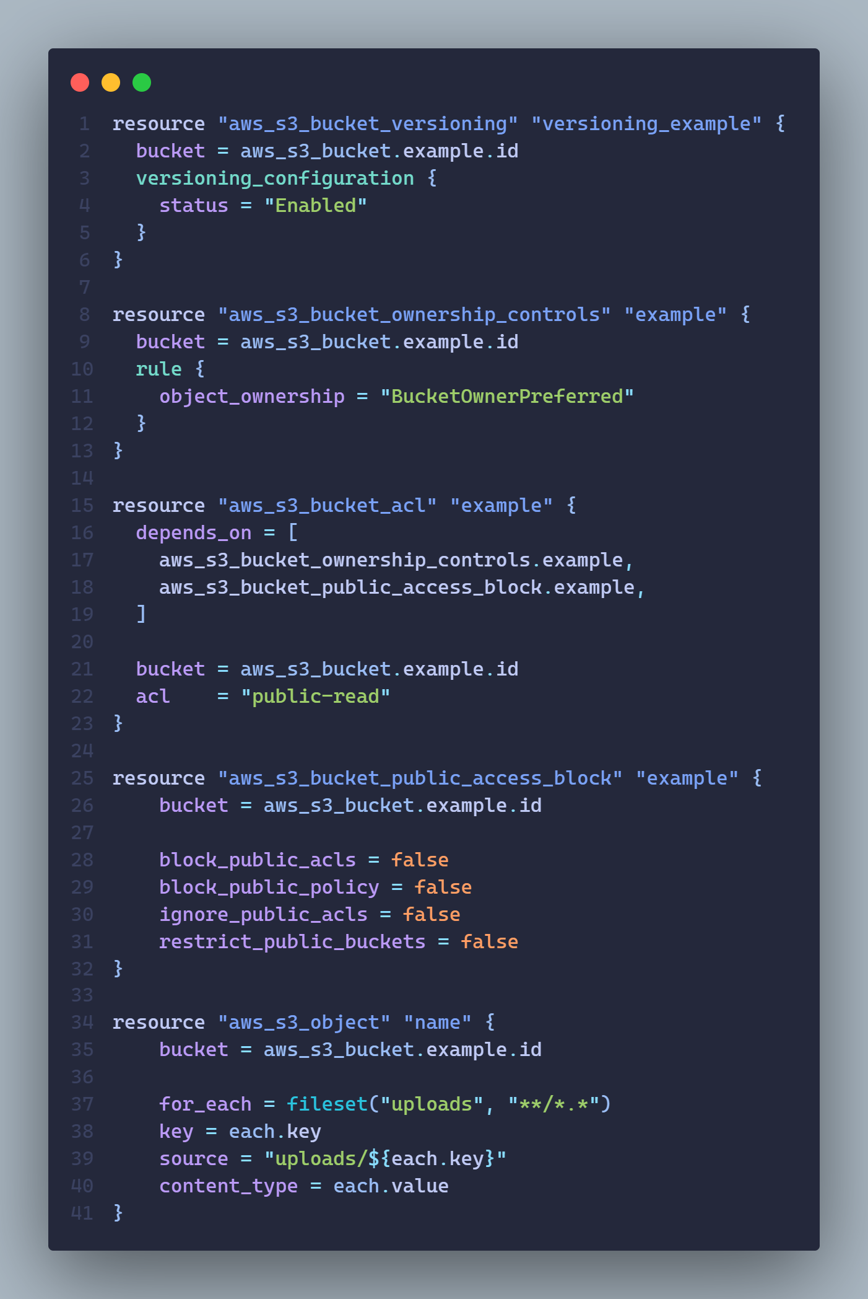

Terraform Plan:

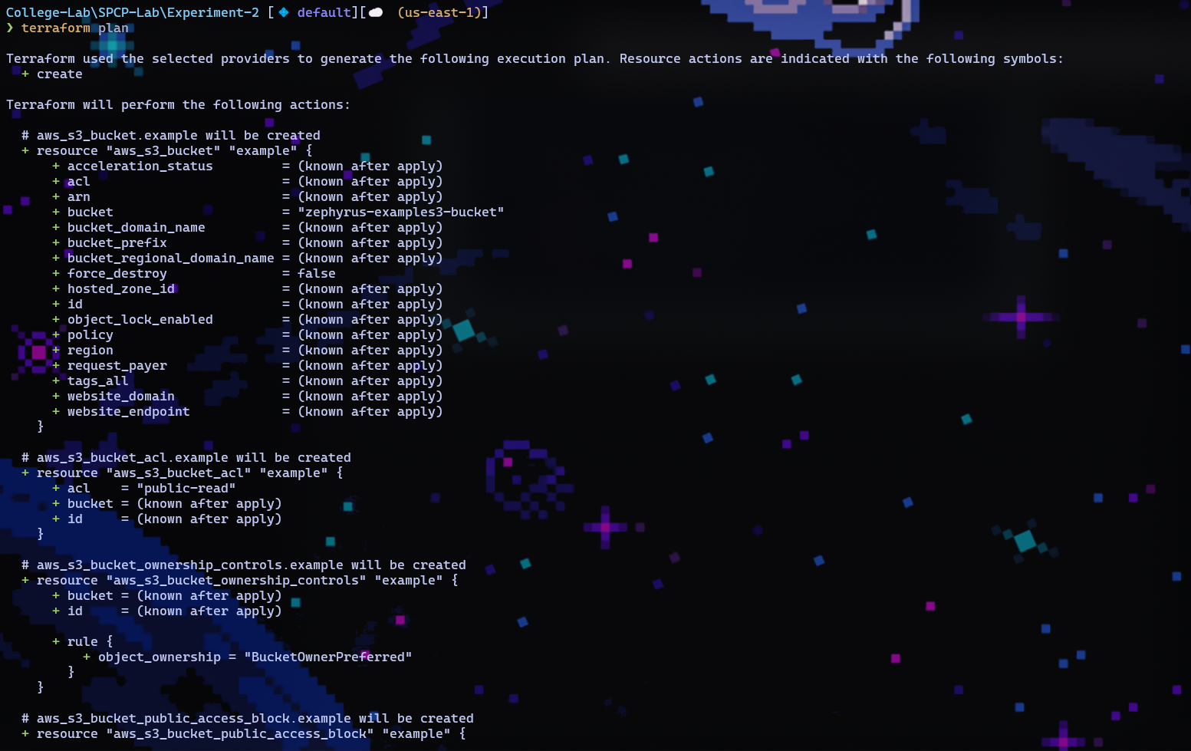

Terraform Apply:

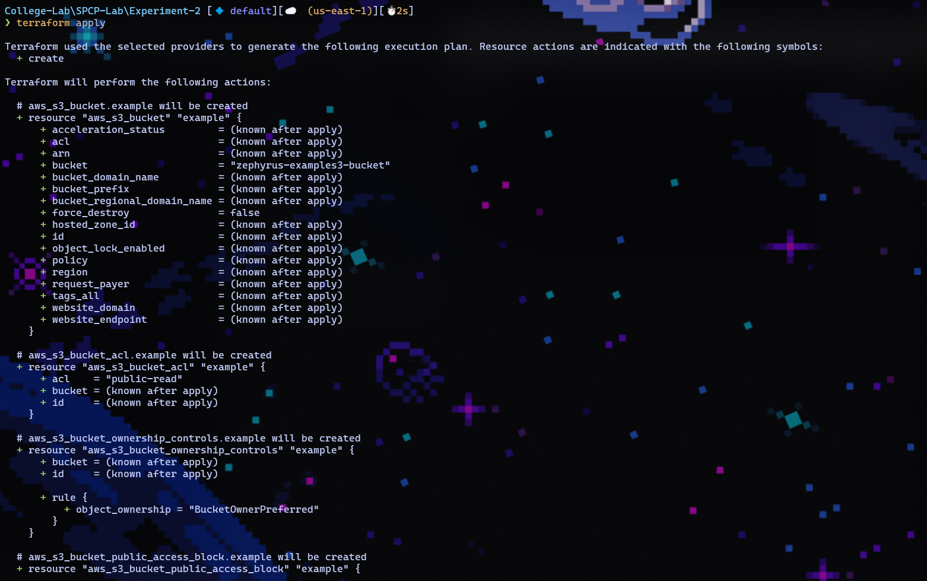

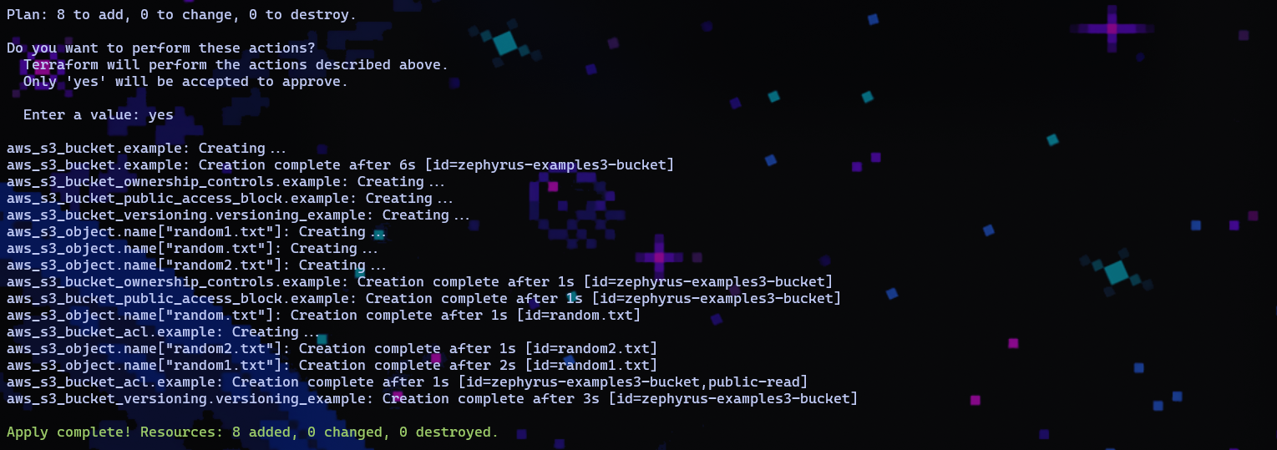

S3 Bucket:

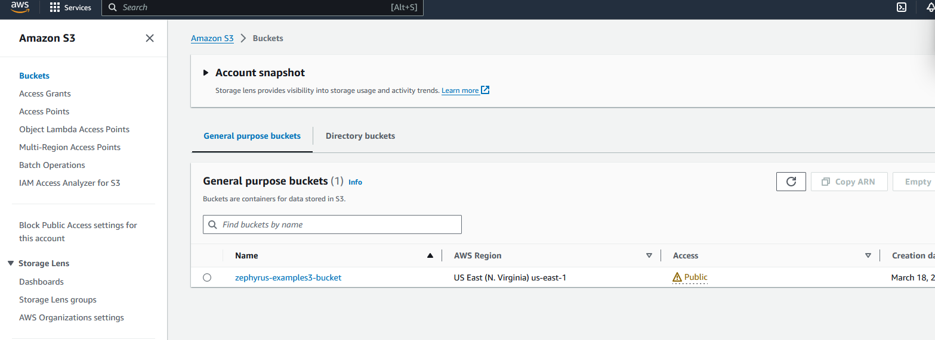

S3 Bucket contents:

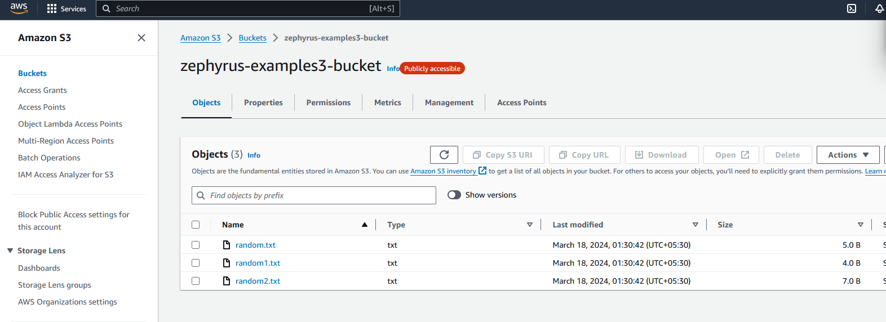

Experiment: 3

TITLE: Creating VPC in AWS Cloud using Terraform

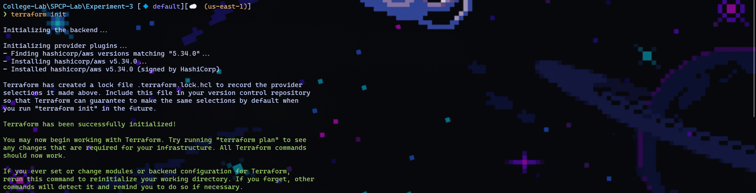

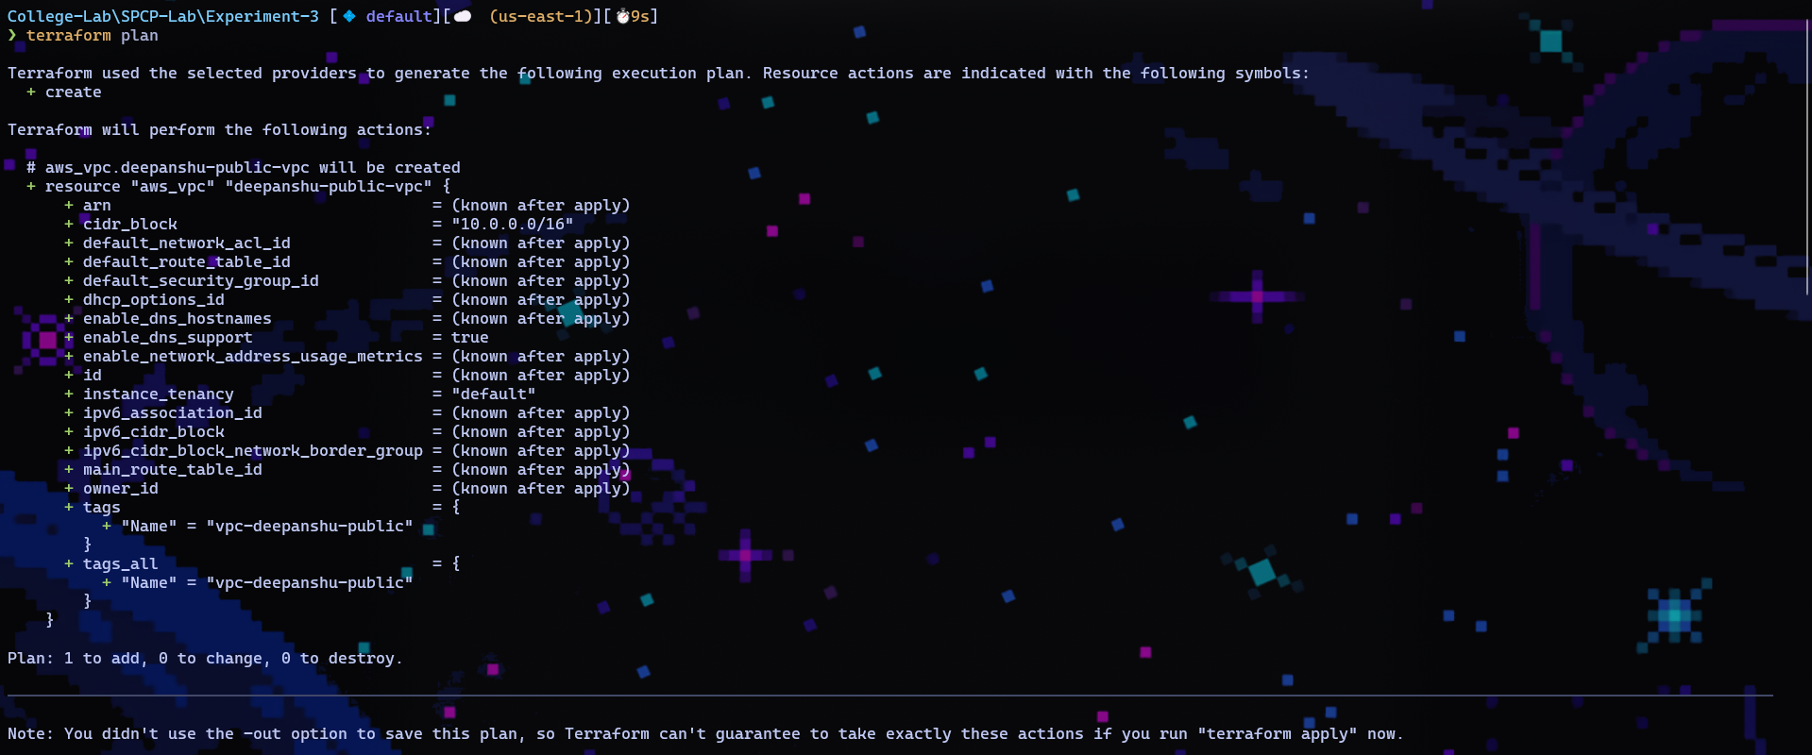

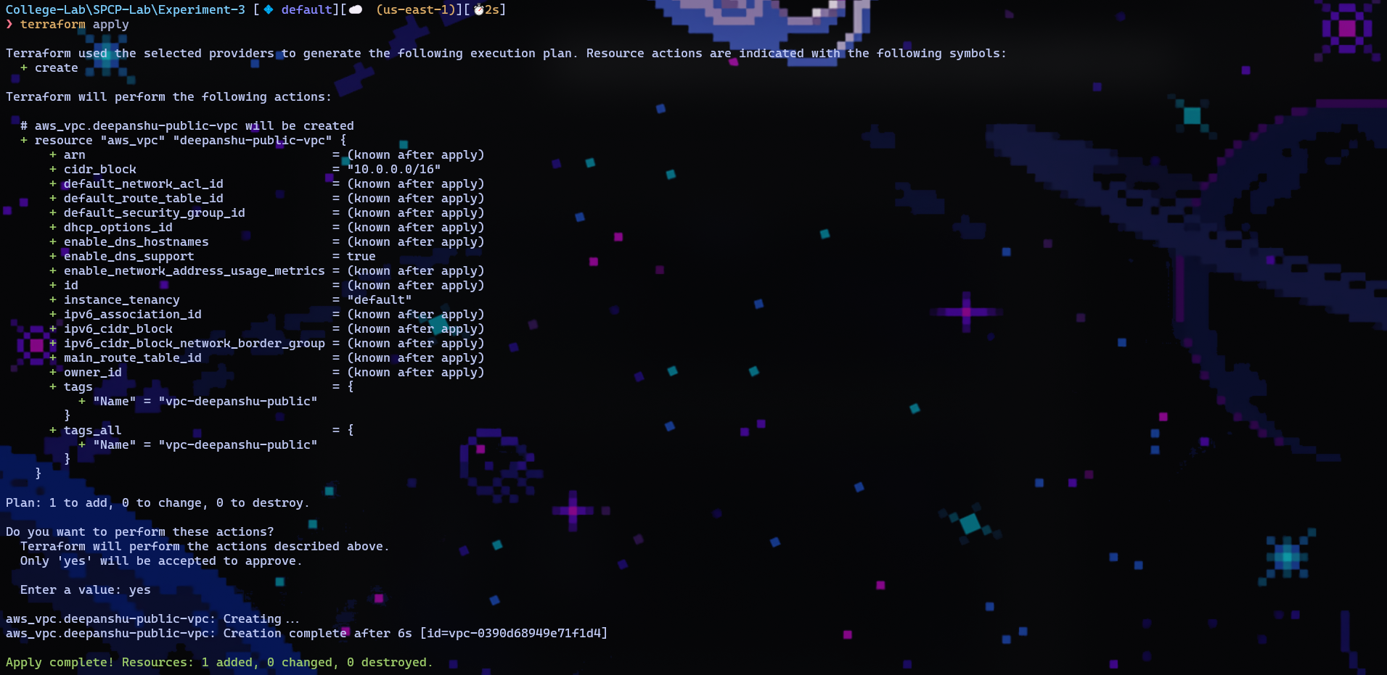

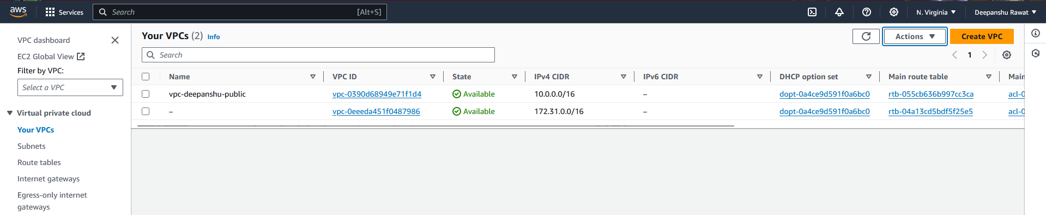

Experiment: 4

TITLE: Terraform Variables

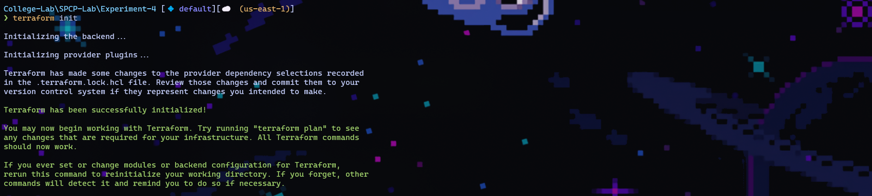

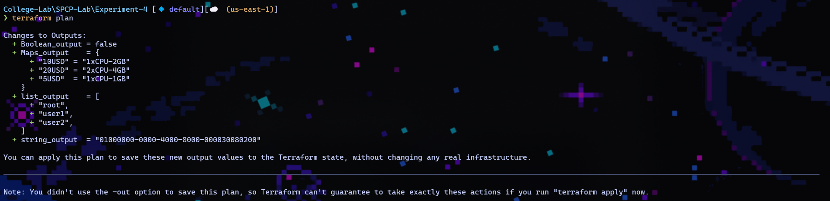

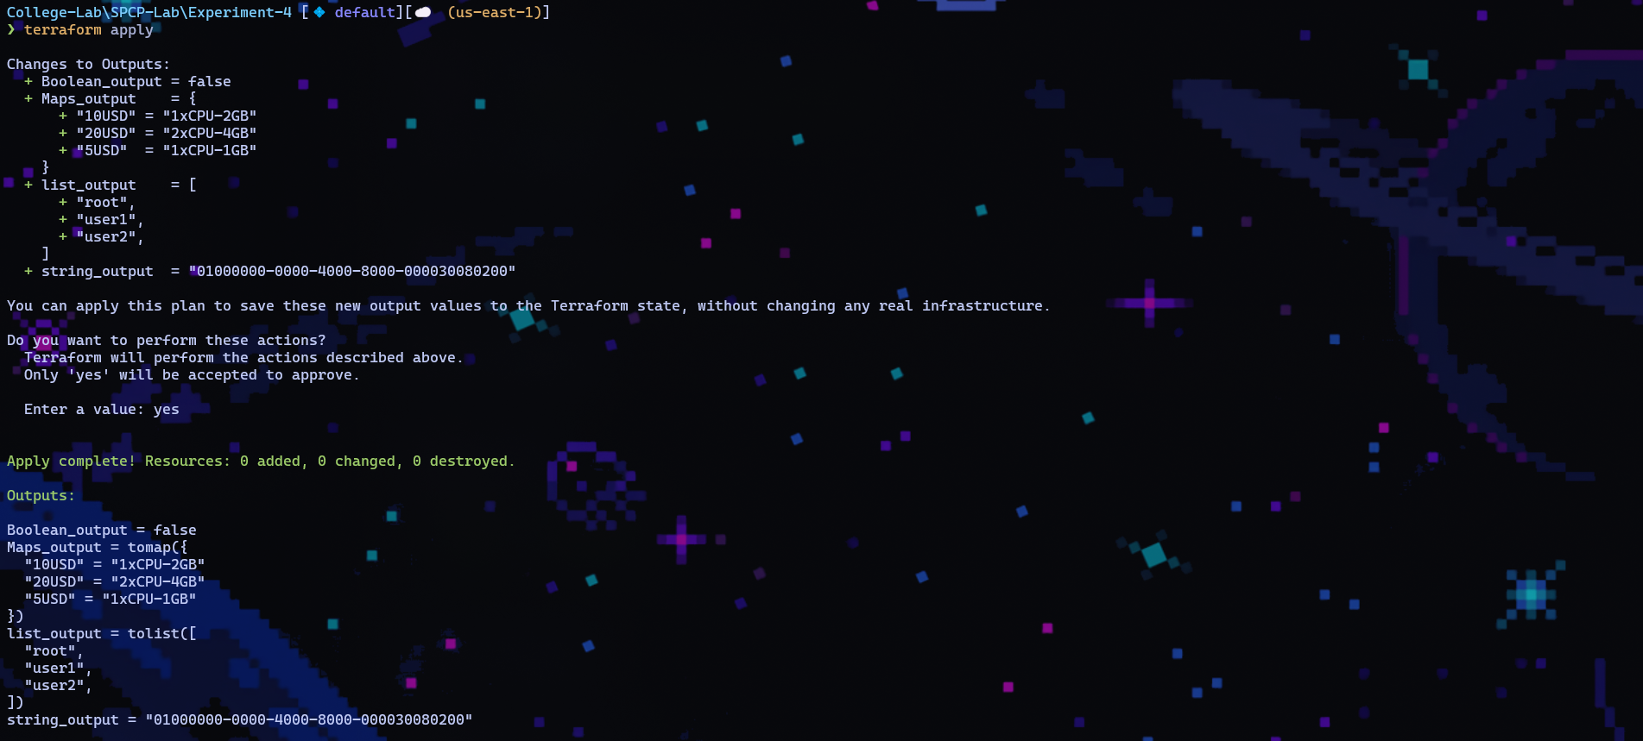

Experiment: 5

TITLE: Using Terraform Variables to run EC2 instance in AWS Cloud

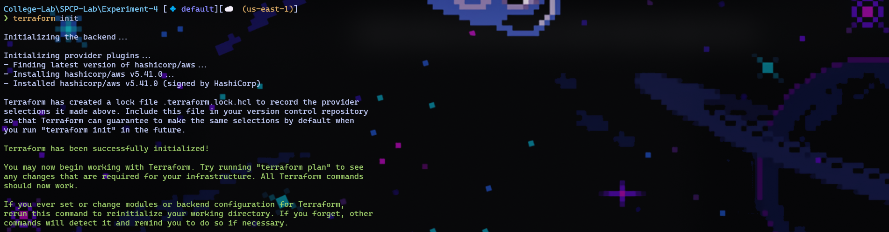

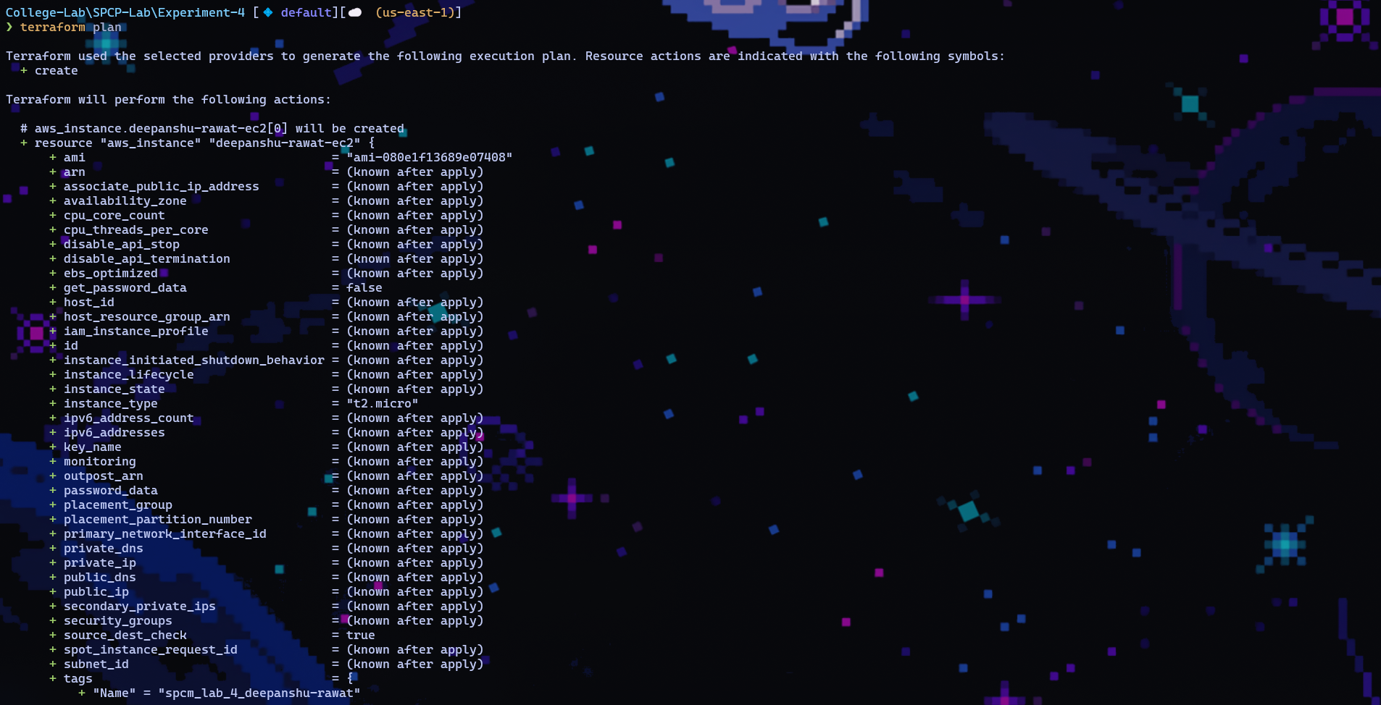

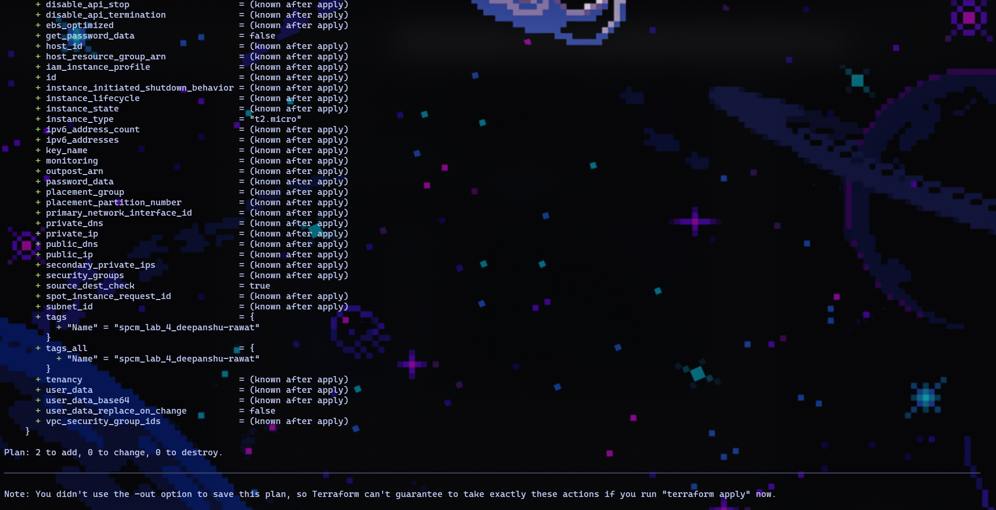

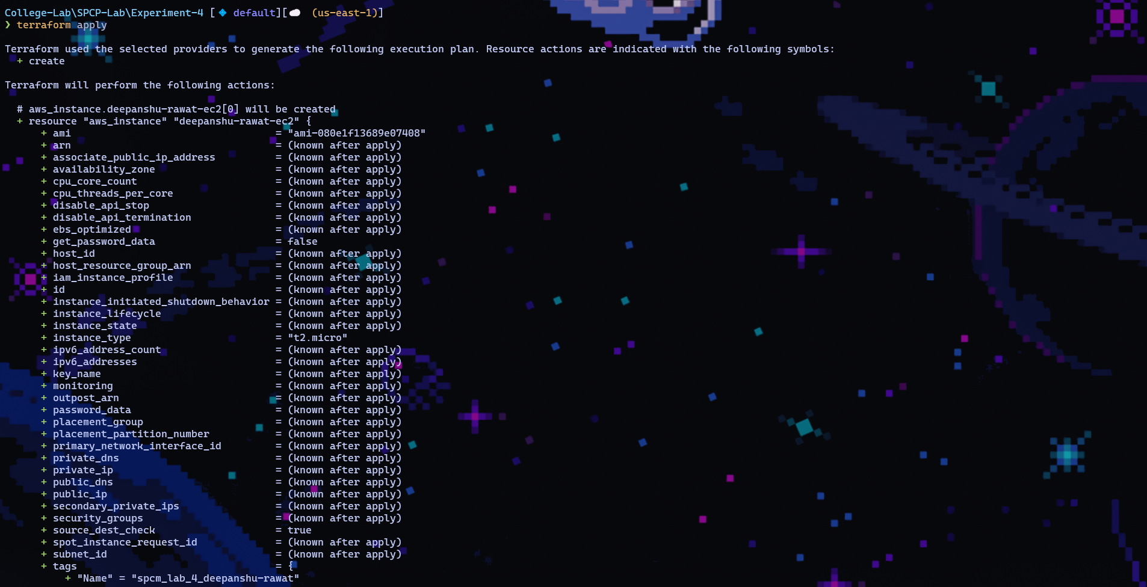

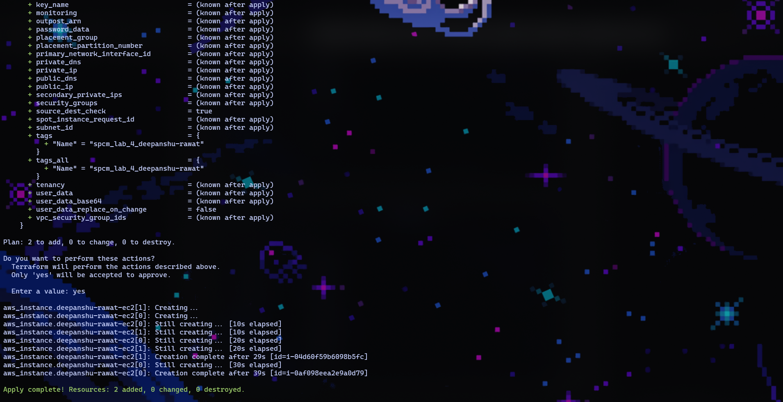

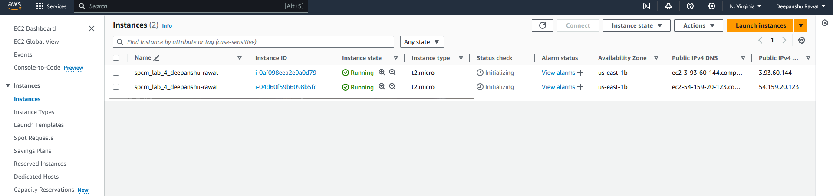

Experiment: 6

TITLE: Create multiple instances using for_each loop in Terraform HCL

